10 DAYS GORILLAS &BIG FIVE (KAZINGA CHANNEL AND RIVER NILE)

Bwindi Impenetrable Forest National Park, Queen Elizabeth National Park and Murchison Falls National Park are most visited in Uganda by tourist among other destinations. Bwindi Impenetrable Forest National Park is known for Mountain Gorillas, The Kazinga Channel in Uganda is a wide, 32-kilometre (20 mi) long natural channel that links Lake Edward and Lake George, and a dominant feature of Queen Elizabeth National Park where Boat cruises are done, Its name was derived from a Greek word 'Nile' for 'valley'. The river begins from the North-eastern section of Africa and flows to the nearby areas adjacent to the equator continuing to the Safari desert until it finally pours into the Mediterranean Sea, In Uganda we do cruises on Nile in Murchison Falls National Park and Jinja.

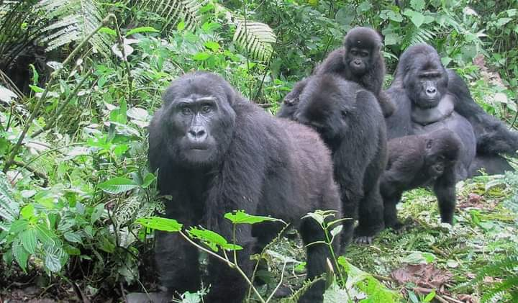

DAY 1: ARRIVAL AT ENTEBBE INTERNATIONAL AIRPORT

You will be welcomed by a representative of FRIENDS NATURE SAFARIS If you arrived at the airport early we may just drive to Lake Mburo National Park its about 4 hour drive from Kampala-Masaka main road we shall have a stopover at the Equator for lunch and photo shoots then continue with our journey to Lake Mburo.Upon arrival we check in at our lodge, then we do a boat cruise on Lake Mburo when back have evening at leisure. Dinner and overnight stay at Mihingo Safari Lodge (Any Equivalent)

DAY 2: KAMPALA – BWINDI IMPENETRABLE NATIONAL PARK

Early morning we shall do safari walk around the park to see animals like Giraffes, Kobs, Zebras and many more, breakfast then leave for Bwind Impenetrable National Park .We shall drive via a scenic route, savanna vegetation and Ankole cattle and precede our drive through the green growth countryside, we shall have lunch on the way and final we arrive in Bwindi and check in at our Lodge for dinner and overnight at Silver Back Lodge Luxury (Any Equivalent).

DAY 3: BWINDI IMPENETRABLE FOREST NATIONAL PARK

In the morning we take our breakfast and assemble for briefing according to the group which we are going to trek/track about the does and donots.This activity is one of highlight of our safari, meeting with the gentle giants of Bwindi, Especially hikers will love the gorilla trekking in the beautiful ecosystem of the park. It is difficult to foresee how many hours you will hike, it may take two to eight hours. Expect to walk a long distance in steep and muddy conditions, sometimes with rain overhead, before you encounter any gorillas. But we found these creatures it is very rewarding and interesting as you observe them closely while they eat, play and rest. A unique and unforgettable experience! For conservation purposes, time spent with the gorillas is limited to one hour. The ranger guide always briefs you on how to behave with these giant apes. After the trek we return back to lodge for lunch and evening at leisure. Dinner and overnight at Silver Back Lodge Luxury (Any Equivalent).

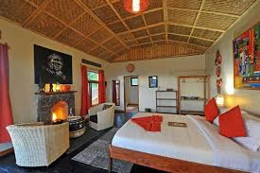

DAY 4: BWINDI IMPENETRABLE TO QUEEN ELIZABETH NATIONAL PARK

After breakfast you can choose to have a guided village walk for a closer meeting with the local community. Learn about their way of living as you walk through coffee, tea and banana plantations. Afterwards we depart to Queen Elizabeth National Park. We will pass the southern sector of the park, called Ishasha and known for the tree-climbing lions and here we expect to see some of the lions resting on the branches of trees. While we continue to our accommodation in the middle of the national park be alert to spot some wildlife like kobs, waterbucks and warthogs while grazing. Dinner and overnight at Mweya Safari Lodge Luxury (Any Equivalent)

DAY 5: QUEEN ELIZABETH NATIONAL PARK. (GAME DRIVE AND BOAT CRUISE

At the park, early morning, wake up take a cup of tea and head for the thrilling game drive at 6:00am. Game to view Lion, Elephant, Leopard, Buffalo, Hyena and a variety of Antelope species. After lunch enjoy the unique 2-hour boat ride on the Kazinga Channel. You will have a chance to view Hippos on close range, have a boat cruise at kazinga chanel, watch other bird species and there after transfer back to the lodge for Dinner and overnight at

• Accommodation: Enganzi Lodge in Queen Elizabeth National park

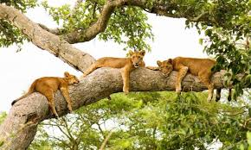

DAY 6: MURCHISON FALLS NATIONAL PARK.

Depart for Murchison Falls National Park in the north western part of Uganda and is the largest park with an area of 3840sqKM. It will take approximately 9-10 hours on road having a stopover at Lake Albert to view the Albertine Rift Valley from there we continue to Bugungu Gate we enter the pay may see animals on our way to the lodge like Buffalos, Lions, Giraffes,Kobs and many more. We check in at the lodge, dinner and overnight stay.

Accommodation: Pakuba Safari Lodge

DAY 7: MURCHISON FALLS NATIONAL PARK (GAME DRIVE AND NILE CRUISE)

Early morning wakeup calls with packed breakfast we, go for the interesting game drive where you may see many animals such as Elephants, Buffalo, Giraffe, Lions, Uganda Kobs and many others if we lucky we can get chance of spotting world‘s rarest shoebill stork at down side of the stream during our game drive after that we break off for lunch. After lunch we go for the amazing enjoyable Nile cruise to the bottom of the mighty falls may spot animals like Hippo, Crocodiles populations/schools, and other animals alongside the river drinking water, the boat will spot at the actual point where you can clearly see the mighty Nile squeezes into 7-meter gorge for photo shorts. Thereafter, we retire at the lodge for dinner and overnight stay.

Accommodation: Pakuba Safari Lodge

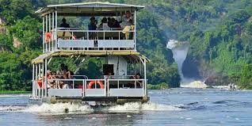

DAY 8: MURCHISON FALLS NATIONAL PARK TO KAMPALA

After morning breakfast we visit top of the Falls to see the mighty Nile being squeezed into a small gorge which creates thunder storm and Raining in this place. After that we depart back to Kampala city Centre.

**DAY 8: KAMPALA TO JINJA (NILE CRUISE)**

In the morning we drive towards Eastern part of Uganda to Jinja Adventure city of East Africa for our day activities, according to our time we do White Water Rafting, Boat Cruise to see the point of the source of the Nile and Tubing the Nile. After that we drive back to Kampala.

**DAY 8: KAMPALA TO ENTEBBE INTERNATIONAL AIRPORT**

Depending on the time of your flight we organize our self and say bye to the PEARL OF AFRICA catch your flight back home.